**Brooklyn torah gazette**

**For parshas Bamidbar 5780**

Volume 4, Issue 33 (Whole Number 185) 29 Iyar 5780/ May 13 2020

**Printed L’illuy nishmas Nechama bas R’ Noach, a”h**

**Parshas Bamidbar**

**It’s Not Where You’re at Now – It’s Where You’re Coming From**

By Rabbi Bentzion Shafier

Founder of TheSmuz.com

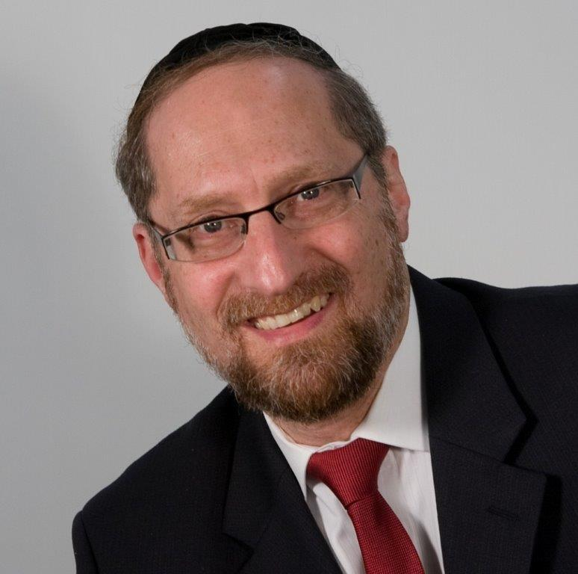

*“Count the heads of the congregation of Israel according to their families, according to their fathers’ houses, by the number of the names, every male according to the head count.”* — *Bamidbar* 1:2

Less than a year after the giving of the Torah, HASHEM told Moshe to again count the Jewish People. The *Siforno* points out that this counting was unique as it counted each person by *name*, whereas thirty-eight years later, when the Jews were about to enter the land of Israel and were counted again, there is no mention of counting by name. The *Siforno* explains that this is because the generation that left Egypt was made up of unique individuals, each worthy of being singled out. The next generation, however, wasn’t on that level, so everyone was counted only by number and not by name.

It is clear from the *Siforno* that the generation that left Mitzrayimwas greater than the generation who entered the Land of Israel. This concept is very difficult to understand. The people who left Egypt were slaves their entire lives. They had almost no education or opportunity to learn. From the time they were children, they had little time to focus on anything other than survival.

The generation who entered the Land of Israel had a very different upbringing. They were all born in the desert. Daily they observed the Glory of HASHEM encamped on the *Mishkan*. On a regular basis, they watched the clouds of glory ushering them from place to place. Each morning, they saw *mon* being delivered to their doorstep.

They experienced the miracle of a rock providing them millions of gallons of water daily. But even more, they weren’t engaged in earning a living; their entire focus was on learning Torah. Taught by the greatest *rebbeim*, unencumbered by physical needs or distractions, they spent their days and nights in yeshiva. Clearly, they knew more Torah than the people who had just left Mitzrayim. How could the earlier generation have been greater than this one?

The answer to this lies in recognizing the ultimate measure of greatness.

**It’s Not Where You’re at –**

**It’s Where You’re Coming From**

It is said in the name of the Gra that when a person leaves this earth, he will stand in front of the heavenly tribunal and be shown a picture. It is a picture of a great person. An individual who changed himself and changed the very world he lived in. And they say to this man, “Why isn’t that you?”

“Me? Little me?” he responds. “You want me to be that great man? A *talmid chacham*. A *tzaddik*?”

And they will answer, “That is you. That is you, had you lived up to your potential, had you become what you were destined to be.”

The point is that they hold up a picture of that man. Not a picture of the *Chasam Sofer*. Not a picture of RebbeAkiva Eiger. A picture of him. Based on his talents and abilities. Based on the times he was born into. The only question they ask is, “How much of his potential did he reach? How much of *him* did he become?’

This seems to be the answer to the *Siforno*. Surely, the generation that entered Israel had learned more Torah than did the generation that came before it. They were far greater Torah scholars. But they were born into it. From their youth, that’s all they knew. That was all that was important in their world — so of course they amassed great fortunes of Torah knowledge. The generation that left Egypt, however, didn’t have those advantages. They didn’t come to study Torah until late in their lives.

Their growth required them to give up everything they had been exposed to. They had to leave behind the very world that they had known. So while objectively they may not have been on the same level, actually they were far greater — because based on where they had come from and the level they reached, they had grown far more.

This concept has a very practical application.

**I Can’t Respect My**

**Father; He’s a Baal Teshuvah**

We live in amazing times, and one of its outgrowths is the *baal teshuvah* movement. Thousands of Jews brought up with nothing have returned to a Torah true life. Their sacrifices are huge, and their personal growth is extraordinary, as they leave behind everything to reclaim the heritage of their fathers. They then marry and bring up the next generation, and their children, who enjoy a yeshiva education, often they rank amongst the finest Bnei Torah.

And wondrous though this is, it sometimes creates a disparity. You see, as intelligent as the parents may be, they began their Torah education late in life. And while their sincerity may be impressive, their skills and actual knowledge is often lacking. Their children, on the other hand, attend the finest yeshivas, and from a tender young age are steeped in Torah learning and mitzvos. It can happen that by 6th grade, the child knows more than the parent. As the child matures, the gap widens and this may lead him to look down at his parents with an attitude of, “My father, he’s a good guy and all that, but what does he know? He’s an *am ha’aretz.* (ignoramus).”

This *Siforno* may be a guiding light on this issue. What we see is that a person’s stature is defined less by who he is now than by how much he has grown, and that growth is credited to him. The scale of measure is where he is coming from. How far has he gone? How much of that change is because of his fortitude and will, and how much the environment that he was in, simply going with the flow? So, it may well be that your father doesn’t know as much as you, yet in the World to Come, he will tower over you. It could be that his Chumash and Rashi is more valuable than your learning all of *Shas*.

*Reprinted from this week’s website on TheShmuz.com This is an excerpt from the [Shmuz on the Parsha book](https://theshmuz.com/product/shmuz-on-the-parsha-book/).*

**Rav Avigdor Miller On**

**Religion inPolitics**

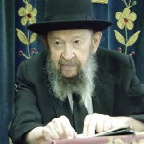

**QUESTION:** What do you say about this subject of mixing religion into politics? It’s an accusation lately brought up against Reagan that he’s mixing religion and politics too much?

**ANSWER**: And our answer is that we want mixing of religion and politics, because everybody is doing it. If Governor Cuomo went and attended a gay banquet to raise money for the Gays for Political Action, isn’t that mixing religion and politics?! Of course it is. That’s his religion. What else is it? Is it public welfare? Is it a benefit for the youth? Is it to make more money for the government? No; it’s a religion.

So just as the liberals have their religion of atheism, a religion of hedonism, a religion of corruption and pornography and breaking down all the values of civilization, so why shouldn’t the President also have religion?

On the contrary, if we see the President speaking about religion, so we might suspect him that he’s trying to get the votes of religious people. And if that’s the case, then he’s getting our votes. Everybody should vote for President Reagan, there’s no question about it. If you didn’t register yet, then this coming Tuesday, the ninth of October is registration day. So go and register, from nine in the morning to nine at night. Find out where in your neighborhood. In this neighborhood it’s on East 8th Street, at the public school. Go register and make it your business to vote.

We need your vote; it’s a *mitzvah rabba* to vote. That’s also one of the things that I say will rise up against a man on the Day of Judgment. You mean to say you’re going to be lax in this great battle against the forces of evil that are trying to overthrow our civilization? Everybody should vote. I registered already. Everybody should register. It’s your business to register.

We want religion in politics. We want Presidents who believe in a Creator. We want Presidents who believe in values of morality and decency. That’s the only foundation of our society. And therefore, our answer is, if a President speaks religion and makes public pronouncements about it, then he is the man that we’re going to vote for.

*Reprinted from the March 16, 2020 email of Toras Avigdor adapted from Tape 524 (October 1984*

**Thoughts that Count**

**For Parshat Bamidbar**

Take a census of the entire congregation of the Children of Israel (Numbers 1:2)

Our Sages note that the giving of the Torah at Sinai required the presence of all 600,000 Jews; if just one had been missing, the Torah would not have been given.

Parshat Bamidbar is always read before Shavuot, the day on which the Torah was given, to remind us of this principle.

Furthermore, it reminds us that it was not enough for all Jews to be present; it was necessary that the Jewish people be united in love for one another. "Israel camped there [before Mount Sinai] as one man with one mind."

This peace and unity is the channel for all Divine blessings, including the greatest of all -- the coming of Moshiach. *(Peninei HaGeula)*

*Reprinted from the Parshat Bamidbar 5755 edition of L’Chaim Weekly.*

**The Transcendental Nature of G-d’s Love for the Jewish People**

**From the Talks of the Lubavitcher Rebbe**

**Rabbi Menachem Mendel Schneerson, Zt”l**

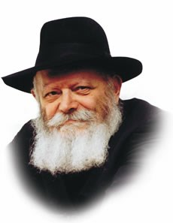

With this week's Torah portion, Bamidbar, we begin the fourth of the Five Books of Moses, known as "Numbers."

Although the Hebrew word "bamidbar" means literally "in the wilderness," the name of the entire book is derived from the fact that it opens with the commandment to count the number of Jews in the Sinai desert.

Obviously, G-d did not need the results of a census to know the exact number of individuals, as Rashi, the foremost Torah commentator explains, the real reason behind the census was to "demonstrate how much they are loved" -- to express G-d's love for the Jewish people.

This seems like an illogical premise.

How does conducting a census demonstrate G-d's love for His people? On the contrary, when a census is taken, no consideration is given for differences. The illiterate and the scholar are both counted as one, no more and no less. The rich and the poor, the virtuous and the not-so-virtuous are equal in the eyes of the census taker.

In truth, however, it is precisely here that G-d's immeasurable love for every single Jew--without exception--is most amply demonstrated.

As far as G-d is concerned, a person's individual talents, personality traits or other external characteristics are unimportant. What is significant to G-d is only the essential inner quality of every Jew--his soul--in which respect all Jews are truly equal.

As human beings, the way we judge our fellow man is sometimes predicated on various conditions: wealth, intelligence, social standing, etc. Because our opinions are based on qualities that are temporary and subjective, they too are subject to modification if circumstances change, i.e., if the rich man loses his wealth or the wise man's knowledge is no longer pertinent.

If, however, we ignore external factors and value our fellow Jew solely because of his essential nature, all Jews will be equal and truly worthy in our estimation.

With this in mind, we can understand how a census is an explicit statement of G-d's unconditional love: G-d does not love us because of our superior qualities or good deeds, or because we agreed to accept and obey His Torah at Mount Sinai. If this were the case, His love would be conditional and would cease, G-d forbid, if we stopped fulfilling His commandments.

The command to conduct a census emphasizes that G-d's relationship with the Jew transcends all external considerations and stems solely from the essential bond with Him that exists by virtue of the Jewish soul.

*Reprinted from the Bamidbar 5755 issue of L’Chaim Weekly, a publication of the Lubavitych Youth Organization. Adapted from Likutei Sichot of the Rebbe Vol. 8*

**More Thoughts that**

**Count for the Parsha**

Every man by his own flag, by the ensigns of their family division Numbers 2:2

Each flag bore the symbol of a different tribe: Reuben, the form of a man; Yehuda, a lion; Ephraim, an ox; Dan, an eagle. *(Ibn Ezra)*

And the charge of the Children of Israel Numbers 3:8

The function of the Levites, which is to "guard the honor of G-d," also serves to protect the Jewish people as a whole, as it states, "G-d is your guardian, G-d is your shadow."

Why a shadow? Because G-d conducts Himself with man in the very same manner as He is served...*(Kiflaim L'Toshia)*

*Reprinted from the Parshat Bamidbar 5755 edition of L’Chaim Weekly.*

**Parashat Bamidbar – The**

**Origins of Jewish Tenacity**

**By Rabbi Eli J. Mansour**

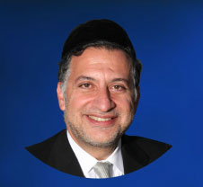P

The Midrash, commenting on the opening verse of the Book of Bamidbar, observes that the Torah has been compared to three natural phenomena: fire, water and a desert. Many Rabbis raised the question of what precisely the Midrash seeks to teach us through this observation. Why is it important for us to know that the Torah is compared to these three phenomena?

One explanation is that the Midrash seeks to draw our attention to the roots of one of the Jewish people’s most outstanding and consistent character trait: our innate stubbornness and tenacity, our refusal to surrender even under the harshest conditions.

Throughout the millennia, Jews have shown their readiness to make enormous sacrifices – including the ultimate sacrifice, of their own lives – for their faith. Whether it was in Germany or Spain, in Russia or in Syria, Jews stubbornly clung to the Torah despite unbearable pressures.

Even here in the United States, where we enjoy the freedom to practice our faith without fear of persecution, we are nevertheless subjected to an unrelenting onslaught of cultural pressures and lures, and yet so many Jews, Baruch Hashem, remain steadfastly committed to Torah study and observance, heroically resisting these pressures.

The Sages teach us that this extraordinary quality originates from three sources: fire, water, and the desert.

It began with Abraham Abinu, who refused to renounce his beliefs even at the threat of being thrown into a furnace. The fire of Abraham has been passed down to his descendants, to the countless generations of Jews who were prepared to give all they had, and their lives, for their faith.

But Abraham’s example was the source of individual devotion, people making the personal decision to make great sacrifices. The concept of a nationwide sacrifice, of the Jewish people collectively sacrificing themselves for their belief, began in the water – at the Sea of Reeds. Following G-d’s instructions, the nation headed straight into the raging waters of the sea. They were not told that the sea would be transformed to dry land. But they trusted that G-d would somehow rescue them, and with unfailing faith, they proceeded onward into the water. This established the precedent of nationwide sacrifice for the sake of G-d..

Still, these two incidents – the heroism of Abraham and of Beneh Yisrael at the sea – were momentary events. What remained to be seen is whether this stubborn, steadfast devotion could endure over an extended period of time. And so the third origin of Jewish tenacity is the wilderness, the forty-year period that Beneh Yisrael spent traveling through an uninhabitable desert.

Their only food was the miraculous daily ration of manna, their only water source was the miraculous traveling well, and their only source of protection from the elements, animals and attackers was the miraculous clouds of glory. Placing their trust in G-d, Beneh Yisrael lived for forty years in a place where there is no possibility of survival through natural means. This set the example of our ability to withstand pressures and hardship even for many years, to refuse to relinquish our faith even through lengthy periods of difficulties and sacrifice.

As mentioned, we face enormous pressures and challenges here in the United States. Day in, and day out, week after week, month after month and year after year, we live with the temptation of material indulgence, the prevalent obsession with wealth, and the pervasive culture of permissiveness and immorality. We have good reason to take pride in our stubbornness, in the beautiful Torah homes, communities and institutions that we’ve built despite these persistent pressures, in the way we have remain stubbornly committed to our traditions rather than accept defeat.

Even today, we live "Bamidbar," in the desert, in a constant condition of challenge and struggle. May we continue to draw inspiration from our ancestors in our attempts to overcome the obstacles in our path, withstand pressures, and remain proudly and steadfastly committed to G-d and His Torah.

*Reprinted from this week’s website of the Edmond J. Safra Synagogue in* Brooklyn.

**Rav Berel Wein on**

**Parshat Bamidbar**

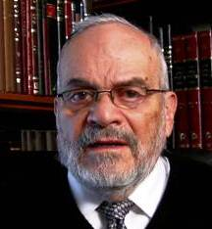

This section of the Torah is entitled, Bamidbar, in the desert. It is hard for us to imagine, though it may be less hard in our current situation than it was before we were put into quarantine, how the Jewish people lived in the desert for four decades. Since they had no gainful occupations and they had no struggle to feed themselves for the miraculous bread from heaven fell and the well of Miriam and of Moshe provided them with water and sustenance.

What did they do with their time? The apparent answer is that they absorbed themselves in understanding, studying, and assessing the laws and values of the Torah. In any event, they had to raise a new generation of people, a generation that would pursue the goal of entering the land of Israel and settling it and creating a more normal, so to speak, Jewish society.

Our rabbis have characterized the generation of the desert as being one of great intelligence, knowledge and understanding. Yet it was a generation of seemingly no purpose because it was doomed to die in the desert and not accomplish the goal that was entrusted to it when it left Egypt.

It was told that it would accept the Torah and then march into the land of Israel. Moshe was successful in having them accept the Torah, but he was unsuccessful in attempting to have them move to the land of Israel. In fact, an element of the people would say that not only would they not go forward to the land of Israel, but they would be willing to retreat and go backwards into the land of Egypt, the land of affliction and of plagues.

It is hard for us to imagine such a generation, with its sole task only to mark time until it passed away and made room for the next generation, which would perforce enter the land of Israel and build there a society. The desert had however positive aspects to it as well. The Talmud teaches us that the Torah was given to a generation that could live in the desert. If one can relieve oneself of desires and of outside pressures and live as though one is in a desert, then the Torah can find a real home and purpose in the life of that person.

The generation of the desert represents to us a two-faced and double-edged society. On the one hand, negative because of its refusal to progress towards its ultimate goal, the land of Israel and, on the other, a society of blessedness, free from daily wants and pressures with the ability to intellectualize Torah into its very being.

In Jewish tradition, the generation of the desert is always represented not so much as a transitional generation but as a wasted generation. One who has opportunity and ability and does not employ that ability to fulfill the opportunity presented, is seen, in the eyes of the Torah, as wasting one's existence. And the Torah has a prohibition against wasting anything, certainly time and opportunities.

Because of this, we are always troubled when reading these portions of the Torah that will follow for the next few weeks and this section of the Torah which bears the name of the desert as its title. We are struck with a feeling of pity and sadness that the generation that had the possibility of being the greatest ended up being a wasted generation, dying in the desert, having no home, and little or no opportunity, after its great start when freed from Egypt.

Every generation must be on the watch, that it should not be a generation of the desert. We can learn to take advantage of situations which allow us to study and to employ intellectual realism, but we have to also beware that a generation of the desert that does not build for the future and does not take hold of its opportunities will not be remembered as a positive and great generation amongst the story of the people of Israel.

We are faced with great challenges, but with great opportunities. And our generation certainly will not be remembered as a generation of the desert, but rather as a generation of Jews who helped build the land of Israel and who have rebuilt the Jewish world, wherever Jews exist.

*Reprinted from this week’s website of Rabbiwein.com*

**A First: Singer Raised Hasidic Signed to Major Label**

**By Curt Schleier**

**Shulem Lemmer is the first Hasidic-born singer to land record deal with a major label.**

Shulem Lemmer’s singing career took a wildly positive turn over the past year.

He went on a major stadium and arena tour, playing to packed houses at Fenway Park in Boston, Citi Field in New York and Vivint Smart Home Arena in Salt Lake City. For Shulem — he goes by one name like those other famous Jewish singing sensations Matisyahu and Drake — these were significant achievements, even if the fans were there to see the Red Sox, the Mets and the Utah Jazz, not him.

Shulem’s travels were a function of a genuinely unique feat: He became the first person raised Hasidic to sign with a major label, Decca Gold, which is part of the Universal Music Group. (The once-bearded and payes-wearing Matisyahu was brought up as a Reconstructionist Jew, later turned to Orthodoxy and has now mostly left the fold.)

Decca Gold released Shulem’s first album, “The Perfect Dream,” late last year. It’s a collection of traditional Jewish and secular songs, from “Jerusalem of Gold” to Rodgers and Hammerstein’s “You’ll Never Walk Alone” to the Whitney Houston and Mariah Carey hit “When You Believe” (from the “Prince of Egypt” soundtrack).

Shulem sings in a rich, passion-filled tenor that carries obvious traces of his roots in the haredi Orthodox Belz community and his work as a cantor, a position he still fills during the High Holidays at Ahavath Torah, a Modern Orthodox synagogue in Englewood, New Jersey. He also makes numerous guest cantor stints throughout the year at various synagogues.

Shulem was raised in Brooklyn, the youngest of eight children in a house where he was always surrounded by music, but not by singers — neither of his parents carried a tune well. Yet both Shulem and his brother, Yanky — a highly regarded cantor at the Orthodox Lincoln Square Synagogue in Manhattan — somehow inherited the singing gene.



**Shulem Lemmer (Photo by Meredith Truax)**

“My father jokes that all the talent comes from him and that he gave it all away and kept none of it for himself,” Shulem says.

Shulem built a level of local renown for both his cantorial skills and performances before Jewish groups. But a [YouTube video](https://www.youtube.com/watch?v=UdwTuToxW9s&feature=youtu.be) is how he came to the attention of Graham Parker, president of Decca Records US.

What follows are condensed excerpts from separate interviews with Parker and Shulem covering an array of subjects ranging from the meaning of success to anti-Semitism.

***JTA: How did you start singing?***

***Shulem:*** I always enjoyed the music playing in my house. My father listened to a lot of cantorial music. My late sister, she passed away when she was only 23, encouraged me to sing and learn songs. At my brother’s wedding, she pushed me on stage. And at that moment I was in a happy place. I was a shy kid and that was kind of an awakening.

My brother, Yanky, and I had the same birthday and we convinced my father to buy us a drum set we shared and later a guitar I taught myself to play. When I went on to study in Israel, I quickly made connections [in the music business] there and sang some backup vocals on recordings. When I came back I joined the [haredi] Shira Choir [in Brooklyn]. I did some solos for them and soon requests came in for me to do more. I released an album in 2015 [titled “Shulem”] and started to build a fan base not only in the secular Jewish world but with a lot of Christians, as well.

***How did you become aware of Shulem and what was your immediate reaction?***

***Parker:*** I found Shulem on YouTube, specifically the “[Chad Gadya](https://www.youtube.com/watch?v=UdwTuToxW9s&feature=youtu.be)” video that he did a few years back. I was immediately aware that Shulem was Orthodox and Hasidic, but I didn’t know which sect of Hasidim he belonged to. It was the combination of his spectacular voice, his personality and being a man of deep faith that made him a compelling person to meet.

***You’re Jewish. How did that impact your thought process?***

***Parker:*** Yes, I am Jewish and my Judaism is very important to me. Professionally, being Jewish didn’t sway me in making the decision about Shulem, although it certainly helped that I knew a fair amount about being observant, traditions, dos and don’ts. I grew up Jewish, married a Jewish man who grew up very observant and we raise our two children Jewish, too. We keep a strictly kosher home and observe Shabbat and the holidays in a way that makes sense for us as individuals and as a family.

***How would you define success for this project?***

***Parker:*** Signing Shulem was a fairly bold move. My goal is to see if Shulem, through his voice, his music and his message of faith, can reach beyond the Jewish community and appeal far more broadly to audiences of all faiths and traditions.

***Shulem, what is your definition of success for yourself****?*

***Shulem****:* First of all, success means being able to provide for my family. [Until recently, Shulem worked part-time as director of marketing for a tech startup.] But also success means being able to reach out and inspire as many people as possible. Music is a universal language, a way to start a dialogue, sending a message of unity, of positivity and hope. I want to spread a message of love between human beings through music.

***Of course — but what about personal music industry aspirations?***

***Shulem:*** I never dream about becoming a celebrity. I’m not looking to become one specific thing. One opportunity leads to another, and I’m happy with everything that comes along.

***Does being Hasidic limit those opportunities?***

***Shulem****:* There will be limitations and challenges. Of course, I’m not going to perform on Shabbos, but there also will be issues that aren’t necessarily that black and white. I would ask my rabbi, based on the situation. I have it in my contract that I can say no to anything that isn’t OK with me religiously. I won’t perform a duet with a woman, for example. They wanted me to do that for the theme song for the movie “Quezon’s Game” [about Philippines President Manuel Quezon’s plan to shelter German and Austrian Jews during World War II, not yet opened in the U.S.]. I said no and so they let me do a solo version.

***Do you ever get tired of being gawked at in public? Is it worse now as a public figure?***

***Shulem:*** It’s always something that happened, even when I was a little kid. But it depends where I am. If I’m in the tristate area, people are already familiar with Hasids. Elsewhere I get stares and people ask me how I get my curls that way.

Worse than that are the online people who hide behind a screen. I started getting a lot of anti-Semitic hate messages. At first I thought it was just words, but then came Jersey City and Monsey. It became a reality and it’s scary. I know it’s just a small number of people, but it doesn’t take many. We do have security. And I know a lot of people, friends and colleagues, are getting armed. That’s the vibe going around.

***How do you get the curls that way?***

***Shulem****:* Mousse, and I just twirl them around my fingers.

*Reprinted from the April 23, 2020 dispatch of the JTA (Jewish Telegraphic Agency)*